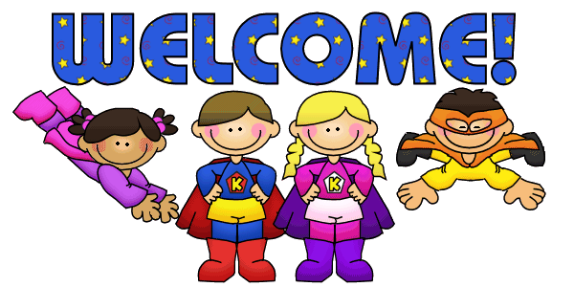

Dear Students,

Welcome to Kindergarten! I am Miss Jones, and I am so excited to be your teacher this year! This is my 9th year teaching at Three Bridges School! I love it here, and I know you will, too! I have been working very hard getting the classroom ready for your arrival! A few fun facts about me: my favorite color is blue, I LOVE sunflowers, I love going to the beach, and I enjoy spending my free time playing softball, going to the gym and being with my nieces and nephews; Lilliana, Emma, Callie, James, Ryan, Raegan and Charlie.

This summer, I spent time at the Jersey Shore. I can’t wait to hear about all the fun things you did over the summer. I am looking forward to sharing some stories with you about my summer adventures!

We are going to have so much fun learning together this year! We will be exploring letters, numbers and even learning how to read and write! We will be reading and writing so many books together throughout the year!

I look forward to meeting you and seeing all of your smiling faces in September.

Love,

Miss Jones 